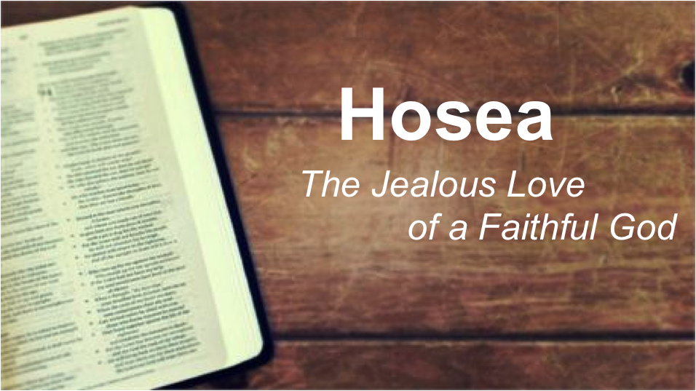

House Groups March-May 2018

Hebron Evangelical Church
Summer Street
Aberdeen
Hosea: The Jealous Love of the Faithful God

Welcome to Hebron’s House Groups 2018! We continue to pray that house groups will be an encouragement as we support one another to be followers of Jesus Christ. A key part of meeting together is reading and helping each other understand the word of God, but also to apply the Scriptures to our lives and hold each other accountable for taking on board what we hear the Lord say to us. You can really help someone to grow in their faith through your participation in this group.

This term we are going to study the book of Hosea. Hosea is one of the twelve “Minor Prophets” (called minor because they are short books), which is a group of Bible books – with the exception of Jonah – that we don’t often read or hear much about. They are precious, and so too is the first of them. The prophecy of Hosea is one where the intensity of God’s love for his people is revealed – Hosea describes The Jealous Love of the Faithful God.

Background
Because this part of the Bible is new territory for many of us, it will be helpful to give some background and therefore set the context of this book – it doesn’t make sense without it! Usually when we hear preachers speak about “Israel” in the Old Testament we think of a single Jewish nation with Jerusalem as its capital. Though that was the case in the days of Kings David and Solomon, after Solomon’s death the country descended into civil war and the once unified nation was split into two:
- Judah was the Southern Kingdom, with Jerusalem as its capital, and was made up of the tribes of Judah and Benjamin.
- Israel was the Northern Kingdom, with Samaria as its capital and made up of the remaining ten tribes.

By the time we come to the book of Hosea, the nations have been divided for over 150 years. Hosea’s message was primarily to the Northern Kingdom of Israel (which is often given the alternative name Ephraim in this book), though Judah is still referred to many times throughout his prophecy. The opening verse tells us that Hosea began his ministry when Jeroboam II was king in Israel (ca. 755 BC), which was by and large a time of peace, prosperity and expansion for the nation. Little did the people realise that it would not last; Israel (and Judah) was prospering because of the downturn in the fortunes of their neighbour Assyria – from ca. 745 BC this Empire would regain strength and eventually overthrow the Northern Kingdom of Israel in 722 BC. The shadows of this future event are found throughout Hosea’s prophecy especially when he pronounces God’s judgement on Israel, and it seems that Hosea prophesied to the nation throughout these tumultuous years (implied by the names of Judah’s kings given in 1:1).

Structure & Things to Look for
The broad structure of Hosea is simple: Ch1-3 are a picture of Israel’s unfaithfulness and the remainder of the book (Ch4-14) is Hosea unpacking the details of that unfaithfulness. However, another helpful way to think of the structure of Hosea is to see four sections; each emphasises some aspect of Israel’s unfaithfulness to God (Hosea puts Israel on trial), then pronounces the consequences of unfaithfulness, but always ends with the hope and opportunity for restoration to God:
- 1:1-3:5 – A Picture of Spiritual Unfaithfulness
- 4:1-6:6 – Israel on Trial: Priests reject knowledge
- 6:7-11:11 – Israel on Trial: Unfaithful to the Covenant
- 11:12-14:9 – Israel on Trial: A Deceitful People

You will notice that almost all of the book of Hosea is written is poetic/verse form. Bearing this in mind can help us – poetry thrives by using imagery that is often used for dramatic effect, rather than to convey a precise point (e.g. Like a bear robbed of her cubs, I will attack them and rip them open (13:8) is clearly not a desirable outcome for God’s people and speaks of utter ruin for them, but the imagery is not meant to give a precise description of how God will bring about their ruin. Moreover, the poetic form can help us to understand difficult imagery (of which there is a lot in Hosea). Modern translations arrange the poetry int couplets- usually these are lines paired together (though some couplets have three lines) – within each couplet the lines are related – sometimes they contrast each other, most often they parallel each other. For example, God says through Hosea, I am like a moth to Ephraim (5:12). On its own, God comparing himself to a moth could mean many things (Small? Weak? Annoying? Attracted to light?), but the other line in the couplet sheds light on this:

I am like a moth to Ephraim,
like rot to the people of Judah

Now you can see the reference to a moth is not about the stature or appearance of the creature it is about its ability to degrade things and cause them to waste away.

Hosea uses a lot of imagery here to describe both Israel and God – in fact some of the imagery you might find jarring – but it gets across the depth of understanding that Hosea must have had through his own traumatic marriage (Ch1-3).

Look out for
- The different metaphors that Hosea uses.
- The number of times that the prophet refers to Israel’s history with God – especially the covenant and the terms of the covenant.
- The condition of Israel’s worship – what mistakes were they making?
- The ways in which God keeps pursuing Israel; the expressions of his unending love for his people. [Don’t let the graphic imagery of judgement distract you from getting this!]

1. Hosea’s Family Life (1:1-2:1)

1 The word of the Lord that came to Hosea son of Beeri during the reigns of Uzziah, Jotham, Ahaz and Hezekiah, kings of Judah, and during the reign of Jeroboam son of Joash king of Israel:
² When the Lord began to speak through Hosea, the Lord said to him, ‘Go, marry a promiscuous woman and have children with her, for like an adulterous wife this land is guilty of unfaithfulness to the Lord.’ ³ So he married Gomer daughter of Diblaim, and she conceived and bore him a son.
⁴ Then the Lord said to Hosea, ‘Call him Jezreel, because I will soon punish the house of Jehu for the massacre at Jezreel, and I will put an end to the kingdom of Israel. ⁵ In that day I will break Israel’s bow in the Valley of Jezreel.’
⁶ Gomer conceived again and gave birth to a daughter. Then the Lord said to Hosea, ‘Call her Lo-Ruhamah (which means “not loved”), for I will no longer show love to Israel, that I should at all forgive them. ⁷ Yet I will show love to Judah; and I will save them – not by bow, sword or battle, or by horses and horsemen, but I, the Lord their God, will save them.’
⁸ After she had weaned Lo-Ruhamah, Gomer had another son. ⁹ Then the Lord said, ‘Call him Lo-Ammi (which means “not my people”), for you are not my people, and I am not your God.
¹⁰ ‘Yet the Israelites will be like the sand on the seashore, which cannot be measured or counted. In the place where it was said to them, “You are not my people”, they will be called “children of the living God”. ¹¹ The people of Judah and the people of Israel will come together; they will appoint one leader and will come up out of the land, for great will be the day of Jezreel.
2 ‘Say of your brothers, “My people”, and of your sisters, “My loved one”.
Hosea 1:1-2:1 NIV(2011)
_________________________________________________________________________________

The role of being a prophet of God was not something people aspired to. God had a habit of asking his prophets to do difficult things – all of them had the task of telling people that they were far from God and in danger of judgement, and sometimes they were to demonstrate that message to the people through their own actions. God commands Hosea to do something difficult in this passage of Scripture, but he does not ask Hosea to do anything that he himself has not already been through.

1. What does God ask Hosea to do? Why is this shocking?

2. What does Hosea’s marriage symbolise?

3. Hosea’s ministry starts by answering over and over again the question: “Why are you marrying Gomer?” What does this tell us about how severely God views the current condition of his people?

4. It is not only Hosea’s wife who has symbolic meaning, but their children as well. Consider each of these children (and again, think about what Hosea would say when asked, “Why did you call your child…?”)
a. Jezreel. At Jezreel, Jehu massacred the wicked king Ahab and his family (2 Kings 9-10). God commended Jehu for doing this (2 Kings 10:30), Yet Jehu was not careful to keep the law of the Lord… (2 Kings 10:31) – the massacre proved not to be spiritually fruitful.

What is Hosea’s son Jezreel declaring to the nation of Israel?

[There is a suggestion that the next two children are NOT Hosea’s (compare 1:3 with 1:6 & 8)]
b. Lo-Ruhamah [No Mercy] (vv6-7). God’s unwillingness to show mercy to Israel is NOT because he has stopped showing mercy – to whom is God still committed to showing mercy?

c. Lo-Ammi [Not My People] (vv8-9). Read Exodus 6:6-7. Why would this message be so difficult for the Israelites to hear?

5. Taken together, what do these three messages tell us about God’s relationship with those who claim to be his people? How easy is it to presume that we are God’s people? Give examples of how we can fall into the same sin as Israel.

6. Consider Hosea 1:10-2:1
a. What makes these verses surprising?

b. Consider some of the language used; what is in mind here? Is God making a new promise here? (cp. Genesis 22:17; 2 Samuel 7; Jeremiah 23:5-6)

c. What does this tell us about what God is like?

7. Interestingly, Hosea 1:10 (and a similar verse in Hosea 2:23) is quoted in the New Testament in Romans 9. There, Paul majors on the sovereignty of God in salvation: Read Romans 9:22-26. Who does Paul see as included in the promises given to Hosea? What are the implications for us? What is an appropriate response?

In your group…

Share points for prayer.
What has challenged you about this passage of Scripture?
Use what is revealed about God here as a springboard for worship in prayer.
Pray for each other’s needs.

2. A Broken Relationship (2:2-3:5)

Read Hosea 2:2-3:5

Last time we saw that the prophet Hosea took an adulterous wife in order to picture the relationship between God and Israel. It seems that only one of their three children was Hosea’s and the names given to them were representative of how God felt towards Israel. However, and unexpectedly, God declared that there was a bright future for Israel. This theme is repeated in the verses we are considering this week.

1. We have seen that Hosea’s marriage is a picture of God’s covenant relationship with Israel. In Hosea 2:2-5 we see what has happened to this once happy union.
a. What are the accusations made against the unfaithful wife? What sort of thinking lay behind Israel’s unfaithfulness to God? Who are the lovers in v5?

b. What has this done to the marriage covenant?

2. Notice the structure of the remainder of chapter 2 – following the accusation in vv2-5 there follows three sections each of which is introduced by the word Therefore (vv6, 9 & 14). Let’s consider what God says he will do in response to Israel’s adultery.
a. In vv6-8, what is God going to do? What is his aim in doing this?

b. Consider vv9-13.
i. What would it mean for God to “take away” and “take back” the things mentioned in v9?

ii. In vv11-13, God links Israel’s sin with their religious practices. What sort of religious observances characterised Israel? Were all of these bad practices?

iii. Israel has been guilty of syncretism (i.e. trying to join different religious practices/worldviews together into one). Discuss some of the ways in which we can be guilty of this sort of thing today. How seriously does God take it?

3. The last of these sections introduced with Therefore begins in v14.
a. How does God speak to his unfaithful people here? Throughout all of Israel’s unfaithfulness, what is God’s greatest desire?

b. God sees a bright future for Israel (N.B. that he uses the formula In that day three times – vv16, 18 & 21). What will be the things that God reverses for his people?

c. The apostle Peter has these verses in mind when he writes to Christians in his first letter –in contrast to those who have stumbled over Christ:

“ But you are a chosen people, a royal priesthood, a holy nation, God’s special possession, that you may declare the praises of him who called you out of darkness into his wonderful light. ¹⁰ Once you were not a people, but now you are the people of God; once you had not received mercy, but now you have received mercy.” 1 Peter 2:10

Compare the underlined sections to the names of Gomer’s children (Hosea 2:23). How are we to relate to these words of Hosea? How costly was it for God to transform those who were not a people into the people of God?

4. What God declared he would do for his people, is what we see Hosea does for his unfaithful wife in chapter 3. These verses help us to see how costly and painful steadfast, restoring love is.
a. Discuss how difficult Hosea’s actions were in chapter 3?

b. Hosea has to buy his adulterous wife out of slavery (v2 – the going rate for a female slave was 30 shekels – Exodus 21: 32), what does this tell us about the condition Hosea’s wife was in?

c. Have you ever seen yourself in this way before God? How does this help us see the costliness to God of saving sinners?

In your group…

Share points for prayer.
What has challenged you about this passage of Scripture?
Use what is revealed about God here as a springboard for worship in prayer.
Pray for each other’s needs.

